Gerard Baden-Clay found guilty of murdering his wife Allison: The calculating, callous heart of a man who had no love for anyone but himself
July 15, 2014 10:05pm
Janet Fife-YeomansThe Daily Telegraph
GERARD Baden-Clay walked into Brisbane Supreme Court stony-faced yesterday, but he wept and shook uncontrollably when he was sentenced to life in jail for the murder of his wife Allison.
Wearing a yellow tie, his wife’s favourite colour, his composure crumpled after the mother of his murdered wife told him exactly what he’d stolen from his three young daughters.
“To have mummy put them to bed one night and wake up the next morning to be told that mummy is missing — what a situation to face,” Priscilla Dickie told him during her victim’s impact statement.
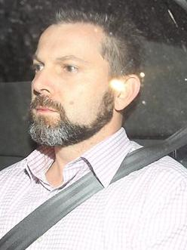
The woman Gerard Baden-Clay had an affair with, Toni McHugh believed that one day she would marry the man she loved. Courtesy: 60 Minutes
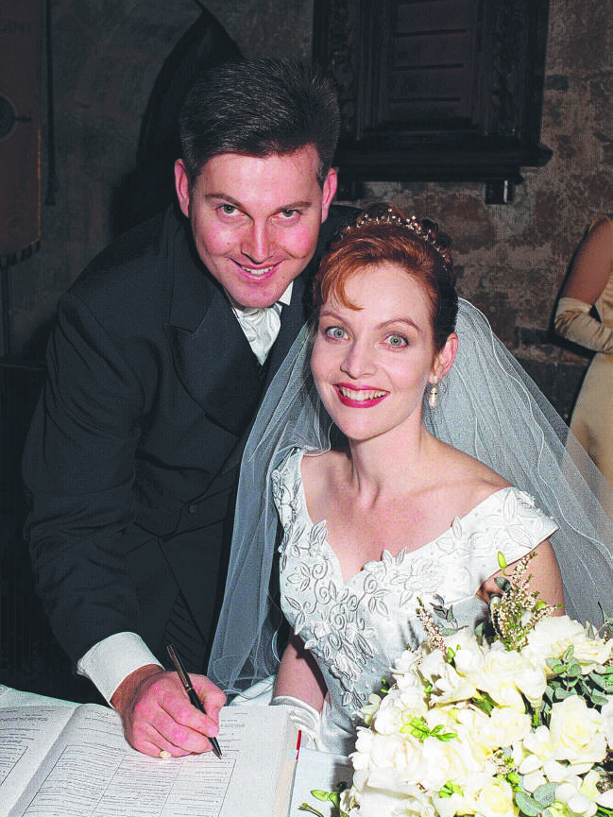



- 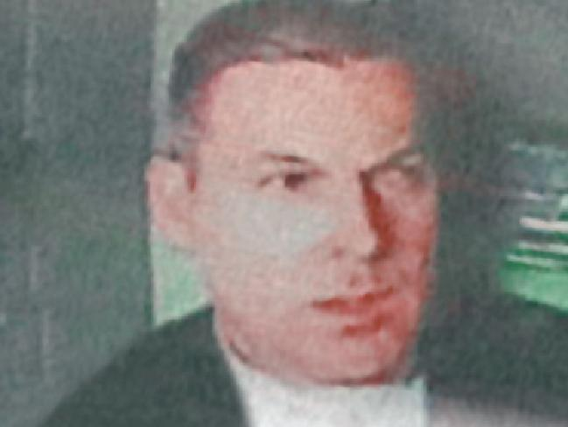

- 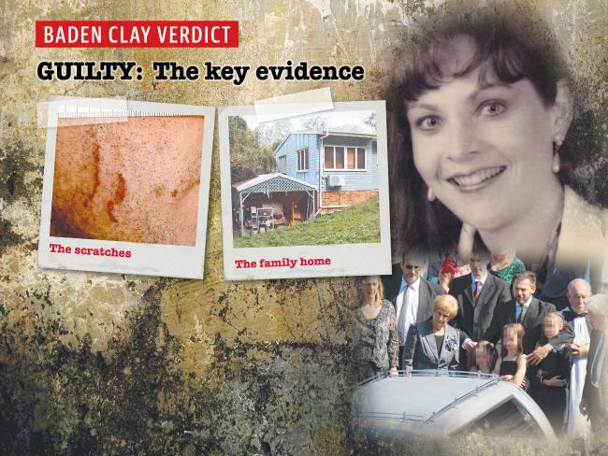

- 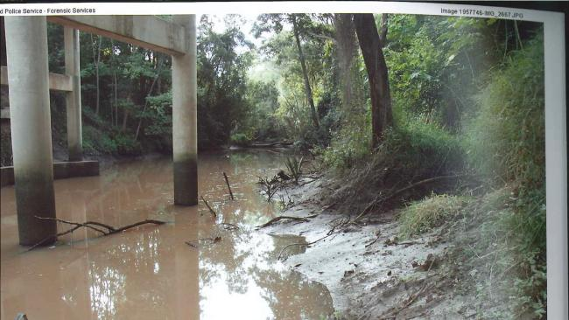

- 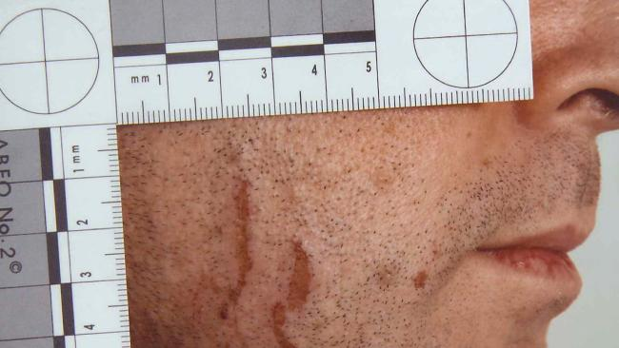

- 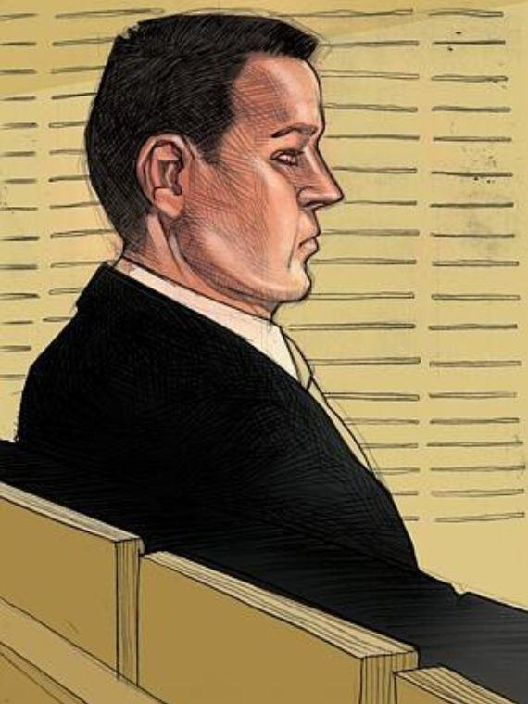

- 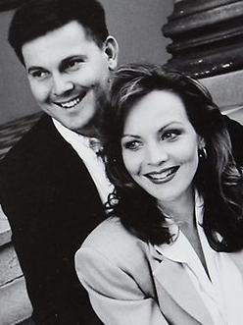

- 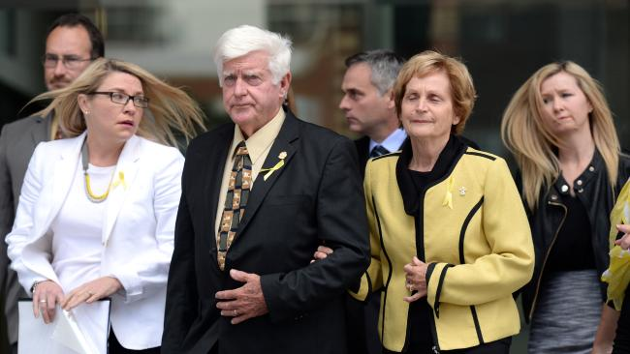

- 

- 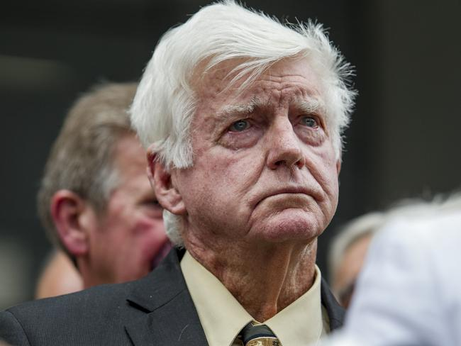

- 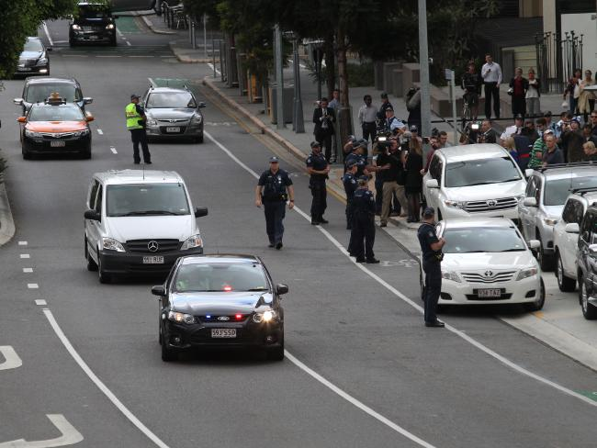

- 

ALLISON REMEMBERED AS KILLER GETS LIFE
Allison’s sister, Vanessa Fowler, whispered the word “bastard” as her father told of giving his blessing when Baden-Clay had asked for Allison’s hand in marriage in 1997, after the couple met at work.
The jury returned with its guilty verdict just before lunch yesterday after the 21-day trial that had exposed the suburban Century 21 real estate agent as a liar, a cheat, a womaniser and a killer.
The great-grandson of Scouts founder Lord Robert Baden-Powell, Baden-Clay, 43, had pretended his wife had disappeared during the night from their home Brisbane’s western suburbs in April 2012.
Her decomposing body was found 11 days later.
Detectives discovered that, far from the family man he pretended to be, Baden-Clay was a serial womaniser with his profile on a swingers’ internet site and a series of affairs.
Justice John Byrne said Baden-Clay had shamelessly pretended to search for his wife, and had used a razor blade to disguise what were really the marks of Allison’s finger nails on his face.
He said Baden-Clay took his wife’s body and dumped it at nearby Kholo Creek.
Baden-Clay had invented the idea of a drug overdose as a ruse and he had shown a profound absence of remorse, Justice Byrne said.
He had gone on to besmirch Allison’s memory during the trial.
“You have no criminal history but you are definitely not of good character,” Justice Byrne told Baden-Clay. “You took a devoted loving mother from her three girls, blighting their lives.”
Baden-Clay will spend a minimum of 15 years behind bars.
The detective who led the investigation, Detective Superintendent Mark Ainsworth, said police had come to feel as though they knew her. “I think we should all agree that Allison was nothing short of a wonderful person, a wonderful mother, friend and daughter,” he said.

GUILTY: KEY EVIDENCE THE MARKS OF MURDER
Janet Fife-Yeomans
SHE left the mark of guilt on his face. As Allison Baden-Clay fought for her life, with her left hand she scratched her husband Gerard’s right cheek.
When police, SES workers and the public mounted a massive search for the mother-of-three in the days after her disappearance on April 19, 2012, detectives were struck by the lack of support and silence from her husband.
While Allison’s distraught family joined the search, Baden-Clay called a lawyer, refused to make a formal statement to police — and grew a beard to hide the scars.
When police forced him to shave, he claimed he had cut himself with a razor blade. He explained away the red abrasions on his chest and neck as a reaction to a bite from a caterpillar that fell on him from acacia trees as he worked in the garden.
Photos of the injuries were sent to the UK’s Serious Organised Crime Agency for advice. Caterpillar experts said they could find no sign of any nests in the trees. Expert after expert gave their opinion — the gouge marks were made by fingernails.
“One of the last things Allison did was to leave her marks on her husband,” her mother Priscilla Dickie said yesterday.
The lengths police went to in their investigation into Allison’s disappearance and death can be revealed after the verdict.
Gerard Baden-Clay’s every move was being monitored. Phone taps picked up conversations between Gerard and his lover Toni McHugh, an employee at his Century 21 real estate branch in Brisbane’s West End. Detectives even bugged flowers at Allison’s funeral in a bid to catch him confessing.
Police thought Baden-Clay might break down if he was alone with the coffin.
However the attempt failed when Baden-Clay arrived to the funeral late with his young daughters in tow.
However, phone taps picked up conversations between him and Toni McHugh. His double life was about to be exposed as his wife and Ms McHugh were due to come face-to-face at a real estate conference on the same day that Baden-Clay reported Allison missing. He had told police he had gone to bed at 10pm and slept soundly until 6am when he discovered his wife missing.
But the analyst scouring his iPhone determined Baden-Clay was awake at some point during the night. At 1.48am he had plugged his phone into its charger.
When Allison’s body was found 11 days later on a muddy bank beneath the Kholo Creek bridge at Anstead, the case against her lying, cheating husband only grew stronger.
A Queensland botanist examined the leaves from six different species of plants found in Allison’s hair and caught in the sleeves of her jumper.
Only two species were found growing in the area of the creek, but all six grew around the Baden-Clays’ home, particularly their back patio, carport and driveway. Right where the cars were parked.
Allison had been on the ground at the back of the carport, next to the couple’s silver Holden Captiva. The Holden Captiva where police found Allison’s blood in the boot, along a plastic trim. A blonde hair was found in the dried blood.
A forensic accountant determined that Baden-Clay was in big trouble. He owed more than $1 million, a debt that would be wiped out by his wife’s insurance and superannuation policies. Together they would bring him a $975,240 windfall.
Two days before he made the triple-0 call to report his wife missing, Baden-Clay used his iPhone to search the term “taking the Fifth” on the internet. It refers to the option in US law to refuse to give testimony under oath on the grounds that it may be incriminating. Just before he dialled triple-O, he searched a Wikipedia entry on “self-incrimination”.
Two months after that call, detectives arrested Baden-Clay. At Indooroopilly police station, he had nothing to say, other than to request a lawyer.

THE CHILDREN: DAUGHTERS SENTENCED TO OWN LIFE SENTENCE MINUS THEIR MUM
With their mother dead and their father serving a life term in prison, the couple’s three young daughters are now in the care of their maternal grandparents. Allison’s mother, Priscilla Anne Dickie, told the court about the girls during her victim impact statement yesterday.
My daughter was a wonderful mother, a devoted wife, a caring daughter, a loving aunt, sister-in-law and good friend to all who knew her — an incredible achiever.
The sorrow and loss of our precious daughter and the long and stressful journey we have had to take to find her killer has been difficult.
Allison did not leave her girls. She has so much to offer them. She just loved them. To be taken from us all so suddenly by such a horrific murder completely devastated me.
I have been consumed by the enormity of this horrific murder of our darling daughter. No one can take the place of a mother and my heart breaks as I do my very best to fill the gap. I have completely and willingly changed my life as a grandma to adapt to my new situation, which is to now wholeheartedly care for Allison’s three daughters.
I have willingly taken on the role of caring for Allison’s daughters and I believe that their resilience to this tragedy is a result of her guidance and love. They miss her terribly and cry for her at night. To have Mummy put them to bed one night and then to wake up the next morning and be told that Mummy is missing, what a situation to face. The girls will never see their mother again! Not just now but forever and ever and ever. They have been condemned to a life sentence without the love and companionship only a mother can give. What can you do or say when dealing with the stress of hugging a little crying girl saying “I want my mummy!” and answering the question, “Does mummy love me?” These are heart-wrenching moments in my life and theirs which never ever should have happened. Over the coming years, there will be many more times like this to handle. It is heartbreaking that these three young girls have been deprived of the love of the most caring and devoted mother.
Throughout this trial I have been deeply hurt by the smear campaign against Allison’s name by her husband and those supporting him. My daughter has been robbed of a LIFE. This man murdered one but has in turn destroyed the lives of many others. You have changed your daughters’ destinies and sentenced them to a journey they must take through life without a mother and all I have left are the memories of a wonderful daughter.

COURTROOM: VERDICT CAN'T ALLEVIATE A FATHER'S PAIN
ONE was a man who carried none of the blame but shouldered it all. The other was a murderer, a man who shattered a family, who lied and cheated, and blamed everyone else for his actions.
Geoff Dickie, devoted father of a murdered woman, stared at his son-in-law and said he would live forever knowing he hadn’t been able to protect his daughter from him.
“From time immemorial it is a known fact that a father’s duty is to protect and care for his daughter,’’ Allison Baden-Clay’s father said in a victim impact statement.
“Due to the mistreatment and subsequent murder of my beautiful daughter, I have failed in my duty as a father and I will have to live with that for the rest of my life.’’
It had been less than an hour since word came — the jury had reached a verdict. After nearly four days a jury of seven men and five women had reached an agreement.
Detectives crowded the aisle as relatives and members of the public filled the seats in court; Allison’s family taking up one side and Gerard’s parents, brother and sister filling the seats directly behind the glassed-in dock where he sat.
At 11.50am the jurors were called into court. All but one stared at the ground as they filed in. One man glanced at Gerard, who sat upright in a suit and striped tie, staring directly ahead.
“Members of the jury, have you agreed upon a verdict?’’ the judge’s associate asked.
“Do you find the accused, Gerard Robert Baden-Clay guilty or not guilty of murder?’’
The jury foreman agreed they had arrived at a verdict: “Guilty, your honour.’’
Allison’s family cheered, cried and hugged while Gerard’s sat unmoving, in stony silence.

THE JUDGE: SUICIDE THEORY WAS PREPOSTEROUS
THE judge presiding over Gerard Baden-Clay’s murder trial has said there was no evidence his wife Allison took her own life.
Justice John Byrne challenged the notion — promoted by defence questioning — that a “depressed” Allison may have committed suicide.
“My concern about it frankly is this,” Justice Byrne said during the trial, without the jury present.
“The evidence doesn’t seem to me at this stage to identify any possible basis in which she could have died from suicide.
“She didn’t drown. She didn’t overdose. She did not fall from the bridge, because there were no fractures. So what is the suicide hypothesis, if it is to be put? What is it?”
Justice Byrne made the comments after the jury left the room following the conclusion of the Crown’s evidence. They were unable to be reported at the time for legal reasons. But the next day the defence announced Baden-Clay would give evidence.
Crown prosecutor Todd Fuller QC told the jury Baden-Clay had blown Allison’s depression out of all proportion to try to avoid conviction.
Justice Byrne made the remarks in discussions with the defence and prosecution about the comments he planned to make in his summing up.
“The reason why I am anxious about it is I don’t want to be put in the position where I am constructing a straw man,” he said at the time. “Where the jury looks at it and says that proposition is preposterous. How could it be suicide? What did she do? Walk 13km in the dark to the bridge along the road, somehow getting entwined in her hair on the way the leaves that were found at the back entry? And then how did she commit suicide when she got there? Because they may reason, as Sherlock Holmes used to, that once you eliminate all that is impossible, what remains, however improbable, must be the truth.

